**Simulation and designing of asymmetric**

**supercapacitor by using biomass materials.**

Prof. Mrs. G. K. Palnitkar Parth Inamdar Rahul Chandanse

PES’s Modern College Of Engineering PES’s Modern College Of Engineering PES’s Modern College Of Engineering

Dept. of Electrical Engineering Dept. of Electrical Engineering Dept. of Electrical Engineering

Pune, India. Pune, India. Pune, India.

[gayatri.palnitkar@moderncoe.edu.in](mailto:gayatri.palnitkar@moderncoe.edu.in) [inamdarparth14@gmail.com](mailto:inamdarparth14@gmail.com) rahulchandanse1@gmail.com

Shrikant GaikwadVandan Chaudhari

PES’s Modern College Of Engineering PES’s Modern College Of Engineering

Dept. of Electrical Engineering Dept. of Electrical Engineering

Pune, India . Pune, India.

[gaikwadshri2002@gmail.com](mailto:gaikwadshri2002@gmail.com) [chaudharivandan@gmail.com](mailto:chaudharivandan@gmail.com)

**ABSTRACT**

In the burgeoning landscape of energy storage, supercapacitors offer a tantalizing glimpse of a future beyond the limitations of capacitors and batteries. This work delves into the exciting realm of sustainable supercapacitors, crafting an asymmetric design that bridges the gap between rapid charge/discharge and substantial energy storage. Harnessing the power of readily available biomass resources like teak wood and orange peels, we fashion activated carbon negative electrodes. The positive electrode boasts a synergistic 1:1 blend of the same activated carbon and the high-performing manganese dioxide. Through meticulous simulations, we illuminate the electrostatic secrets and performance characteristics of these sustainable electrodes, unlocking their immense potential for a greener tomorrow. Our research aspires to not only contribute valuable insights into eco-friendly energy storage solutions but also ignite further advancements in this burgeoning field. This is a future powered by supercapacitors, and we are paving the way with every sustainable step.

Supercapacitors are characterized by their long cycling life and high power density, offering promising application prospects in various fields. Generally, SCs can be categorized into two main types: electric double layer capacitors (EDLCs) and Pseudo capacitors. The capacitance of EDLCs primarily stems from the adsorption of anions and cations on or near the electrode/electrolyte interface, and this phenomenon is closely linked to the surface area of the electrode material. Porous carbon materials, such as activated carbon, carbon nanotubes, carbon nanofibers, and graphene, are commonly employed electrode materials for EDLCs. These carbon materials exhibit high specific surface area and good conductivity, contributing to enhanced specific capacitance. Despite the superior conductivity and surface area of graphene and carbon nanotubes compared to other carbon materials, activated carbon has emerged as an ideal electrode material for EDLCs due to its ease of processing, lower cost, adjustable surface area, relatively inert electrochemical properties, adjustable porosity, and the presence of electrocatalytically active sites for reactions, enabling its large-scale utilization in commercialized supercapacitors.

* Keywords: Supercapacitors, Asymmetric design, Activated carbon electrodes, Manganese dioxide.

**INTRODUCTION**

Supercapacitors, also known as ultracapacitors, have been gaining attention in the energy storage market due to their unique characteristics such as high power density, long cycle life, and environmentally friendly disposal. The primary technology of supercapacitors relies on charging an electrical double layer at the interface between the electrode and electrolyte, where high surface area carbons are used. The main obstacle to the widespread use of supercapacitors is their high cost compared to batteries. The most expensive component of a supercapacitor is the electrode, and reducing its cost is essential for making the device commercially viable. Activated carbon, derived from various carbonaceous precursors, is the most commonly used electrode material due to its high porosity and electrical conductivity. While activated carbon can be obtained from a wide range of carbonaceous precursors, lignocellulosic biomass is particularly promising. However, the use of biomass native to the Indian subcontinent as a precursor for activated carbon requires further investigation. Moreover, there is a lack of literature that optimizes the activation method of the precursor specifically for its application in supercapacitor electrodes.

In the initial stages of research, various biomass sources abundant in India were activated through pyrolysis in a nitrogen atmosphere. The resulting activated carbon was then used to fabricate supercapacitor electrodes, and their specific capacitance and equivalent series resistance were evaluated. After extensive experimentation, teak wood were identified as the most suitable precursor. Further research was conducted to determine the optimal activation method and development process for supercapacitor electrodes using teak wood and orange peels.

In the next stage of the research, i.e. hardware process, after the hardware material selection the activated carbon is made from that material, selection of separator, in the next stage of the research, the hardware material selection is done and from the hardware material the activated carbon is made. The next step consists of the pasting of activated carbon and mno2 on the particular electrodes according to the procedure. For the testing of the material, the connections are made as per the circuit diagram. For the readings, the first 3 readings are taken for 3 minutes charging and it's respective discharging time and then 5 readings are taken for 1 minute charging and it's respective discharging time.

From the readings it is concluded that the teakwood has the better charging- discharging time and specific capacitance.

**LITERATURE SURVEY**

As we know that, renewable energy source importance is rapidly increasing so that, the research paper gives idea about the activated Carbon/MnO2 composites as electrode for high performance supercapacitors. It also gives the general idea about the energy storage devices such as supercapacitor for which is mainly consists of positive electrode of MnO2/Carbon electrode composites.

It signifies that, supercapacitor is consists of negative activated carbon electrode and positive electrode made up from the composites of activated carbon and MnO2.Due to using these electrodes, the supercapacitor shows very attractive energy storage characteristics because it has high energy density. It also shows rapid charging and discharging and long term stability.

By using the MnO2 as the positive electrode the supercapacitor becomes the emerging energy storage device because MnO2 is environment friendly, it has low cost and most important it has high power capability. It simplifies that, MnO2 provides a source of high specific capacitance and higher energy density. It has wide potential range which provides maintained stable performance over different charge/discharge state.

The activated carbon used in the positive and negative electrode is made up from the biomass materials such as Tamarind seeds, coconut shell, coconut husk, bagasse, etc.

In this research, after software procedure the actual or specific capacitance of the different biomass material is obtained and from that, it is found that the specific capacitance obtained from the activated carbon which is made from the bagasse material is much higher than the other biomass material as coconut husk, coconut husk , tamarind seeds.

**METHODOLOGY**

1. **Software process**

* **Selection of Software** : Different software like COMSOL Multiphysics, Fusion 360, Ansys, MATLAB were tested and out of which COMSOL Multiphysics have all required physics interphases and hence COMSOL is selected for simulation.
* **Geometry :** In COMSOL software 3D geometry was created which replicate the overall structure of the supercapacitor.
* **Selection of materials :** There are different materials which can be used for designing of supercapacitor. But biomass materials are used to make supercapacitor environment friendly.
* **Selection of physics interphase :** There are different physics interphases available in COMSOL out of which we have selected electrostatics and electrical circuits.
* **Selection of study :** Stationary and time dependent study are selected to analysis the supercapacitor.



**Fig. 1. - 3D Geometry in COMSOL**

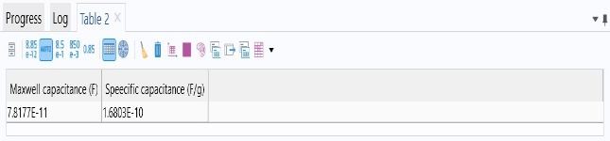

**Fig. 2 – Capacitance and specific capacitance**

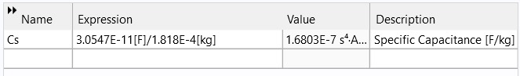

**Fig. 3 – Expression for specific capacitance**

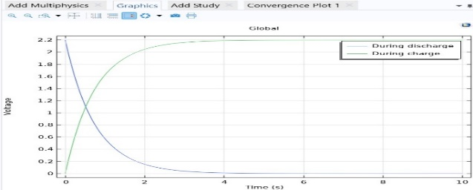

**Fig. 4 – Charging and discharging graph (voltage)**

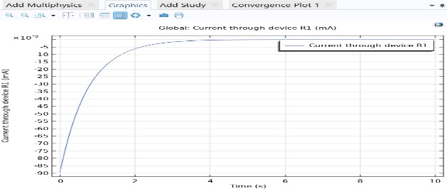

**Fig. 5 – Charging graph (Current)**

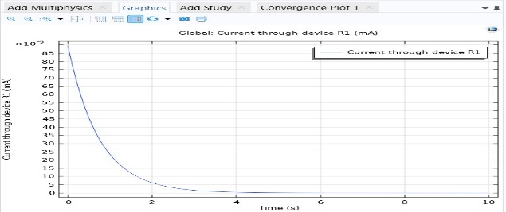

**Fig. 6 – Discharging graph (Current)**

**Software Result**

|  |  |  |
| --- | --- | --- |
| **Material** | **Orange peels** | **Teakwood** |
| Specific Capacitance (F/gm) | 3.0547E-11 F/g | 2.2830E-10 F/g |

**Table no.1. Software result**

1. **Hardware process**

* **Selection of materials :** There are different materials which can be used for designing of supercapacitor. But biomass materials are used to make supercapacitor environment friendly.
* **Properties of material :**

|  |  |  |
| --- | --- | --- |
|  | **Orange peels** | **Teak wood** |
| Density | 0.58 - 0.814 g/cm^3 | 0.6 - 0.7 g/cm^3 |
| Thermal conductivity | 0.3 - 0.5 W/M.K | 0.12 - 0.20 W/M.K |
| Moisture content | 80 - 88 % | 10 – 14 % |
| Pore size | 51.6 um - 56.4 um | 10 um - 50 um |
| Surface area | 40.84 - 45.42 m^2g | 1-10 m^2g |
| Specific Heat capacity | 2 - 2.24 J/g-k | 0.58 J/g-k |
| Value heat transfer | - | 4500 - 4800 kcal/kg |
| Thermal Expansion coefficient | 6 - 9 u/m-k | 10-50 u/m-k |
| Ash content | 3 - 4 % | 0.5 - 2 % |

**Table no.2. Properties of material**

* **Making of hardware :**

**Shape and constructional details of supercapacitor:** In the construction of supercapacitor required materials are polyethylene sheets as a separator and a mesh sheet on which carbon has to be placed.

The anode and cathode of supercapacitor has been made up of mesh sheet for this the lower portion width is selected as 1 CM and length is 3 CM. For upper part 0.5 CM width and 3 CM length.

Just for not looking the same both anode and cathode ,the mesh sheet for anode is slightly cut at the top just to identify anode and cathode mesh sheet.

In making of supercapacitor the anode and cathode are superimpose on each other.

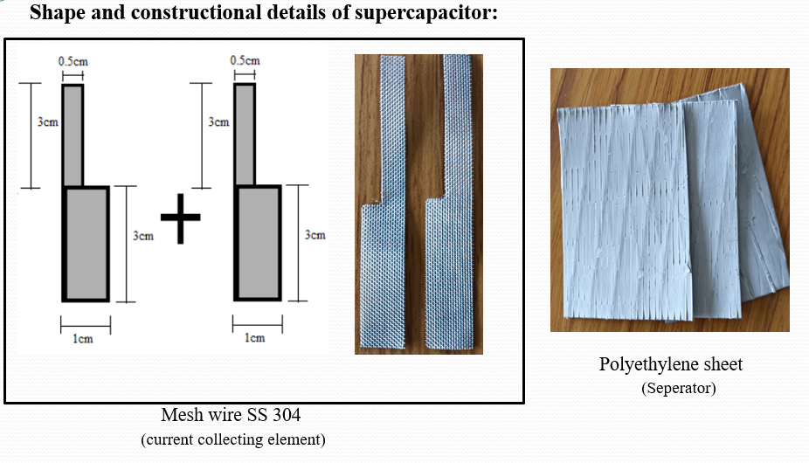

**Construction process :**

For hardware, on anode mesh sheet mixture of activated carbon and MNO2 is placed.

On cathode mesh sheet only activated carbon is placed.As per the circuit diagram the connections have been made after that the material of orange peels and teak wood one by one placed in the solution of K2SO4 and distilled water.

The voltage has been set as 2.2 V. Firstly the materials has been charged for 3 min for 3 times simultaneously time to discharge has been noted. In the second part materials has been charged for 1 min for 5 times and at the 5th time corresponding voltage current and time to discharge has been noted.

Based on these data the calculations are performed to find the capacitance of these materials.

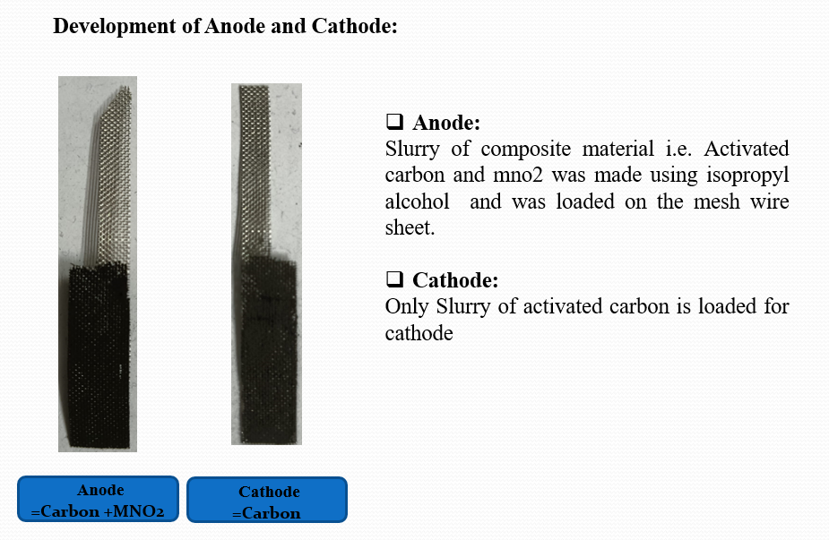

* **Single cell of supercapacitor :**

Single cell of supercapacitor consist of three layers. one is anode layer. in the middle polyethylene is used as a separator and lastly cathode is placed.

Such a way single cell of supercapacitor has been made for testing. Following figure shows the single cells of supercapacitors of the orange peels and teak wood.

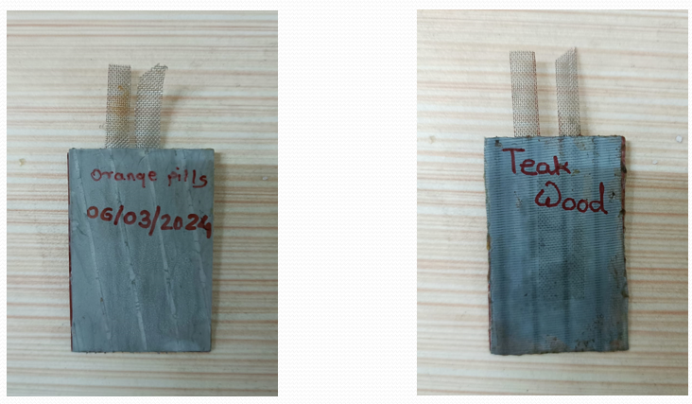

fig. 6.5 – Cell of supercapacitor

* **Testing of material :**
* For testing of materials the connections have been made as per the circuit diagram.
* Single cell of supercapacitors like ( orange peels/teak wood ) material has been dipped in the solution of K2SO4 and distiled water.
* The voltage has been set to 2.2 V then the material has been charged for 3 min for 3 times and discharged time has been checked.
* Then charging for 1 min has been performed for 5 times and time to discharging has been checked.
* At 5th time the time to discharge , corresponding voltage and current has been note down.
* With the help of these data calculations have been done.

**CONCLUSION**

Simulation of supercapacitor made of 2 different materials (Orange peels, Teak wood) have been tested and have found the specific capacitance of the materials and also the charging and discharging graph of the four materials have been found.

The current study concludes the hardware and software process of designing, simulation and testing process of the supercapacitor. The current study was able to identify the Teak wood crush and orange peels as a suitable precursor for activated carbon to be used as a supercapacitor's electrodes. The main conclusion from this study is that the material used as the electrodes of the supercapacitor are made up from the biomass materials.

Due to use of this materials, E-waste generated is less, the material is easily available as well as easily decompose. Hence it is much more environment friendly than any other electronic materials. The size of the supercapacitor is equivalent to the normal supercapacitor as well as the cost is also less.

**REFERENCES**

[1] Activated Carbon/MnO2 Composites as Electrode for High Performance Supercapacitors. Jang Rak Choi 1,2, JiWon Lee 1, Guijun Yang 1, Young-Jung Heo 1 and Soo-Jin Park 1,*.

[2] Long-term cycling behavior of asymmetric activated carbon/MnO2 aqueous electrochemical supercapacitor Thierry Brousse a*,*∗, Pierre-Louis Taberna b, Olivier Crosnier a, Romain Dugas a, Philippe Guillemet a, Yves Scudeller a, Yingke Zhoud, Fr´ed´eric Favier d, Daniel B´elanger c, Patrice Simonb.

[3] Nanostructured Manganese Dioxide for Hybrid Supercapacitor Electrodes Jon Rodriguez-Romero, Idoia Ruiz de Larramendi * and Eider Goikolea *.

[4] MnO2/Carbon Composites for Supercapacitor: Synthesis and Electrochemical Performance Dan Wu1, Xiubo Xie1, Yuping Zhang1, Dongmei Zhang2, Wei Du1*, Xiaoyu Zhang1* and Bing Wang3.

[5] Nanostructured Manganese Dioxide for Hybrid Supercapacitor Electrodes Jon Rodriguez-Romero, Idoia Ruiz de Larramendi * and Eider Goikolea

[6] MnO2/Carbon Composites for Supercapacitor: Synthesis and Electrochemical Performance Dan Wu1, Xiubo Xie1, Yuping Zhang1, Dongmei Zhang2, Wei Du1*, Xiaoyu Zhang1* and Bing Wang3.

[7] Development of Three Electrode System for Optimizing the Parameters of Hybrid Capacitor Priti Kadam1*, R. M. Holmukhe1 and P. B. Karandikar2.

[8] Carbon-Based Electrode Materials for Supercapacitor: Progress, Challenges and Prospective Solutions, Xian Jian, Shiyu Liu, Yuqi Gao, Wei Tian, Zhicheng Jiang, Xiangyun Xiao, Hui Tang and Liangjun Yin.

[9] Supercapacitor Based On Active Carbon Electrode: Review Tri Surawan Department of Electrical Engineering, Faculty of Engineering Universitas Indonesia Jakarta, Indonesia Department of Mechanical Engineering, Faculty of Industrial Engineering Universitas Jayabaya Jakarta, Indonesia tri.surawan@gmail.com Purnomo Sidi Priambodo Department of Electrical Engineering, Faculty of Engineering Universitas Indonesia Jakarta, Indonesia [p.s.priambodo@ieee.org](mailto:p.s.priambodo@ieee.org).

[10] Zhenhui Li, Ke Xu*, and Yusheng Pan Recent development of Supercapacitor Electrode Based on Carbon Materials.

[11] Review of carbon-based electrode materials for supercapacitor energy storage Richa Dubey1 & Velmathi Guruviah1.